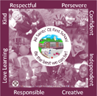

All Saints’ CE First School

End of Year Expectations
for Year 4

This booklet provides information for parents and carers on the end of year expectations as compiled by the staff using National Frameworks/Curriculum requirements.

All the objectives will be worked on throughout the year and will be the focus of direct teaching. Any extra support you can provide in helping your children to achieve these is greatly valued.

If you have any queries regarding the content of this booklet or want support in knowing how best to help your child please talk to your child’s teacher.

Multiplication Tables that all children should know by the end of Year 4.
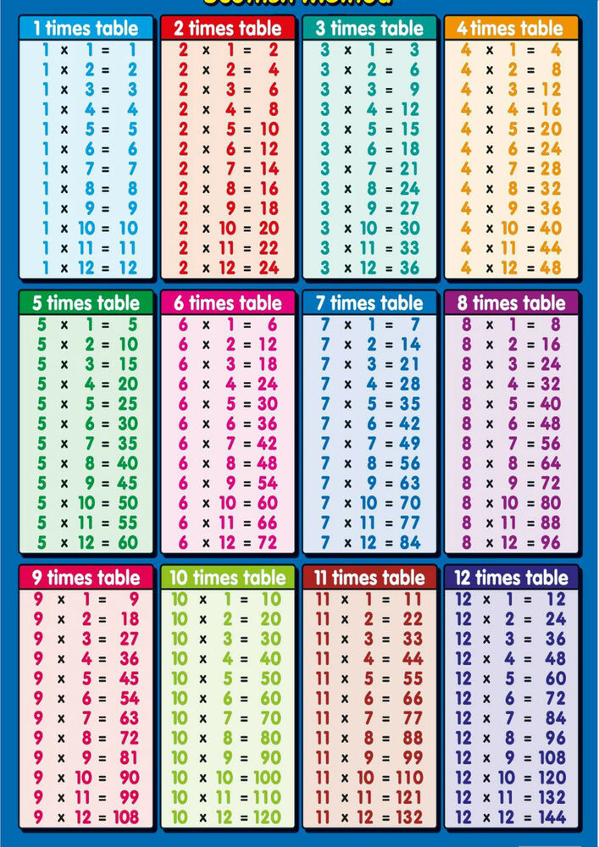
This means to be able to recall any times table fact and the related division fact from all of these tables.

Mathematics Expectations:
- Know all times tables facts up to 12x12
- Recall all corresponding division facts for times tables up to 12x12
- Count in multiples of 6,7,9,25 and 1000
- Find 1000 more or less than a given number
- Recognise the place value of each digit in a 4 digit number
- Read Roman numerals to 100
- Add and subtract numbers with up to 4 digits using the formal written methods of columnar addition and subtraction
- Estimate and use inverse operations to check answers and solve problems
- Multiply 2 digit and 3 digit numbers by a 1 digit number eg if I know 3x6=18 then I know that 30x6=180
- Recognise simple equivalent fractions e.g. 5/10 is equivalent to 1/2
- Count up and down in hundredths
- Add and subtract fractions with the same denominator
- Recognise and write decimal equivalents of any number of tenths or hundredths e.g 0.7 is 7/10
- Compare numbers with the same number of decimal
places up to two decimal places.
- Measure the perimeter and area of shapes
- Read, write and convert time between analogue and digital, 12 and 24 hour clocks
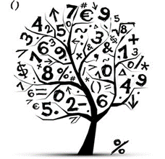
- Identify acute and obtuse angles and
compare and order angles up to two right
angles by size
- Describe positions on a 2-D grid as
coordinates in the first quadrant.

Year 4 Multiplication Check
In June, every year 4 in the country will be required to take a statutory multiplication check. The result of the check will be a pass or fail. In order to pass the children must get all 25 questions correct. They will have no more than 6 seconds per question, and the questions will be a complete mix of times tables from 1x1 to 12x12. Therefore, children must be able to mentally recall any of their times tables without having to count up from the start. The majority of our mental Maths homework this year will be to support the children learning their tables. Thank you in advance for supporting us with this.

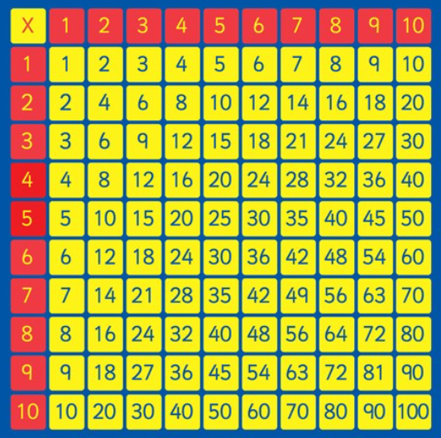

Writing Expectations:
- Use accurate punctuation (capital letters, full stops, exclamation marks, questions marks, commas to mark phrases and lists)
- Use the possessive apostrophe to show plural and singular possession
- Use joined handwriting which is legible.
- Plan their writing by discussing and recording ideas and follow the plan in longer piece of writing.
- Write in paragraphs and change paragraph when appropriate.
- Be able to create settings, characters and a plot.
- Write stories with a clear beginning, middle and extended ending.
- Use language that excites the reader e.g. powerful verbs and adverbs.
- To proof read work for spelling and punctuation errors and edit as necessary.
- Extend sentences using a using a wide range of conjunctions e.g. which, therefore, however, so that, but.
- Use grammatically correct sentences.
- Use fronted adverbials for example At the end of the day, At the stroke of midnight, Under the clock,
- Punctuating direct speech, correctly with inverted and reporting commas

Print Used in School
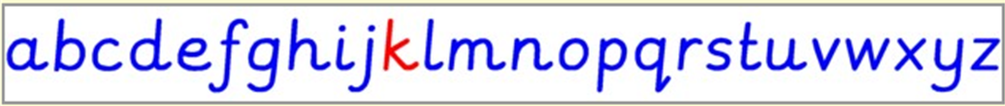
Reading Expectations:
Expected Book Bands
Autumn Term and Spring Term: Grey
Summer Term: Dark Blue
Please note: This is the book band your child should be reading in school. They may have a different coloured band at home to consolidate skills.
- Use punctuation in the text (commas, question marks & exclamation marks) to vary expression.
- Apply their growing knowledge of root words, prefixes and suffixes, both to read aloud and to understand the meaning of new words they meet.
- Increase their familiarity with a wide range of books and genres. (Read different genres of books, not just choose the same types of books to read).
- Read books that are structured in different ways and notice the similarities and differences between these.
- Discuss words and phrases that catch the reader’s attention and think about why they have been used.
- Answer questions about a text by drawing ideas from more than one paragraph.
- Make predictions and explain their reasoning using evidence from the text.
- Identify how language, structure and presentation contribute to meaning.
- Retrieve information from non-fiction texts.

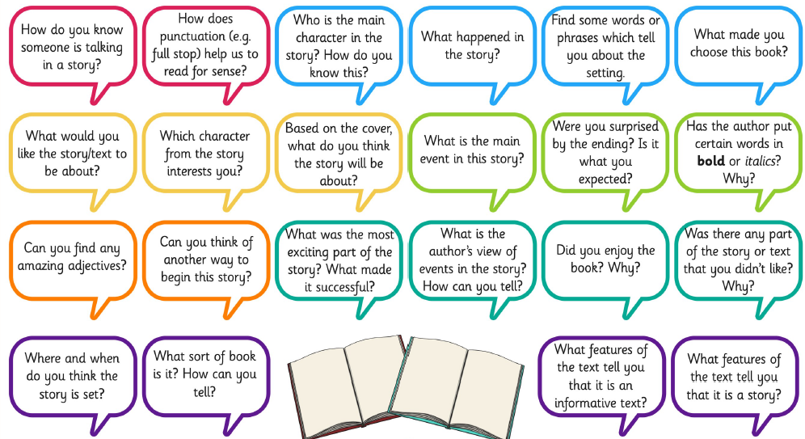
Reading Comprehension Questions.
Asking questions similar to these develops the reading skills required in Year 4.
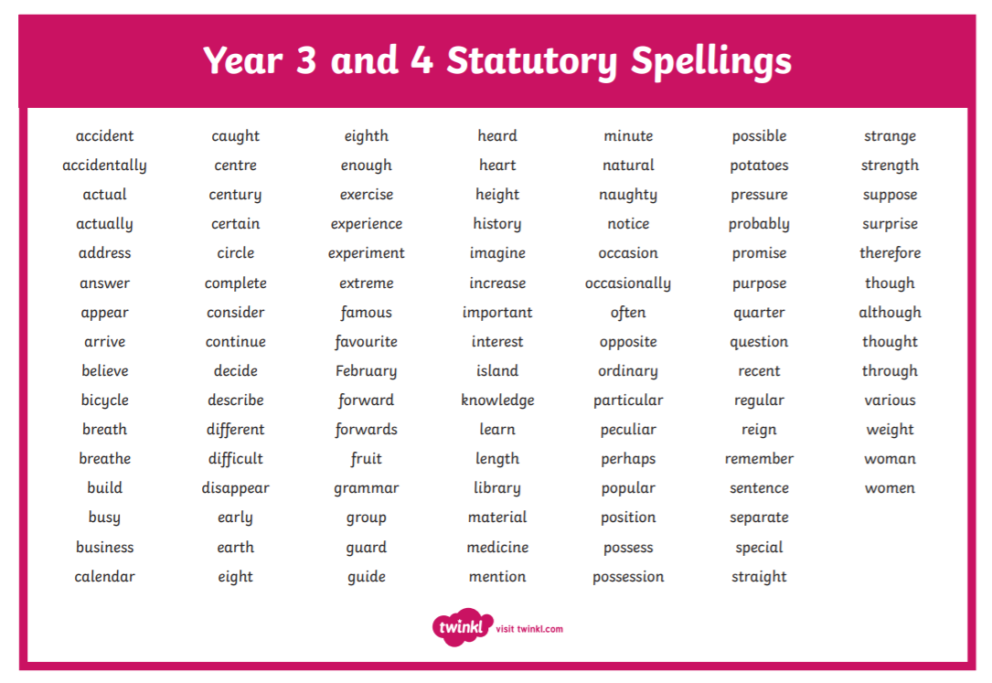
Useful Websites to support learning:

www.ictgames.com
www.phonicsplay.co.uk
www.topmarks.co.uk
www.bbc.co.uk/education
www.crickweb.co.uk
www.nrich.maths.org
www.literacyshed.com
www.oxfordowl.co.uk
www.educationcity.com
www.readtheory.org
www.mymaths.co.uk


