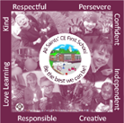

All Saints’ CE First School

End of Year Expectations
for Year 3

This booklet provides information for parents and carers on the end of year expectations as compiled by the staff using National Frameworks/Curriculum requirements.

All the objectives will be worked on throughout the year and will be the focus of direct teaching. Any extra support you can provide in helping your children to achieve these is greatly valued.

If you have any queries regarding the content of this booklet or want support in knowing how best to help your child please talk to your child’s teacher.

Multiplication Tables that all children should know by the end of Year 3.
This means to be able to recall any times table fact and the related division fact from all of these tables.
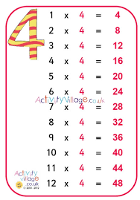
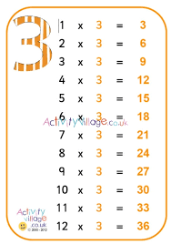
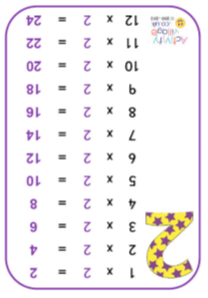
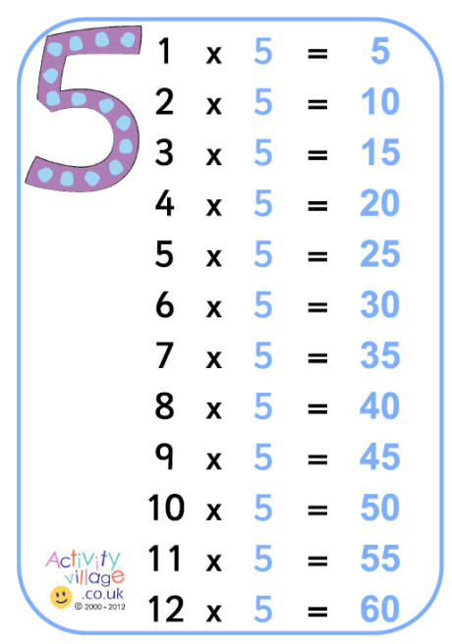
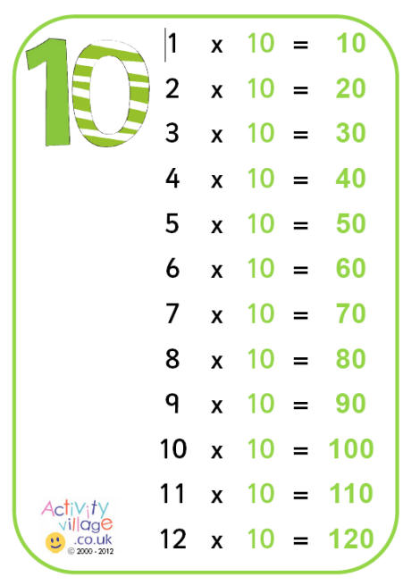
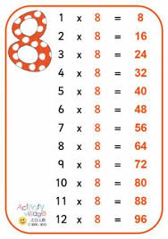
Mathematics Expectations:
- Know all times tables facts from the 2, 3, 4, 5, 8 and 10 times tables
- Recall all corresponding division facts for the 2, 3, 4, 5, 8 and 10 times tables
- Count in multiples of 6,7,9,25 and 1000
- Find 10 or 100 more or less than a given number
- Recognise the place value of each digit in a 3 digit number
- Add and subtract numbers with up to 3 digits using the formal written methods of columnar addition and subtraction
- Estimate and use inverse operations to check answers and solve problems
- Find simple fractions of a set of objects e.g. ¼ of 20.
- Count up and down in tenths.
- Add and subtract fractions with the same denominator
- Compare numbers with the same number of decimal
places up to two decimal places.
- Measure the perimeter and area of shapes
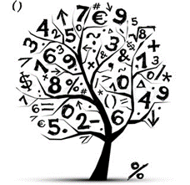
- Read, write and convert time between analogue and digital clocks
- Identify right angles and say whether angles
are greater or less than a right angle.
- Interpret and present data in pictograms
and bar charts.


Writing Expectations:

- Use past or present tense consistently in
one piece of writing.
- Use first or third person consistently in one piece of writing.
- Use accurate punctuation (capital letters, full stops, exclamation marks, questions marks, commas in lists)
- Use joined handwriting which is legible.
- Plan their writing by discussing and recording ideas and follow the plan in longer piece of writing.
- Be able to create settings, characters and a plot and write stories with a clear beginning, middle and end.
- Use language that excites the reader e.g. powerful verbs and adverbs.
- To proof read work for spelling and punctuation errors and edit as necessary.
- Extend sentences using a using a range of conjunctions e.g. and, but, so, because
- Punctuating direct speech correctly with inverted commas
- Use headings and subheadings correctly in non-fiction writing.
- Beginning to write in paragraphs.
- Use an apostrophe for contractions e.g. can’t, don’t, won’t

Print Used in School
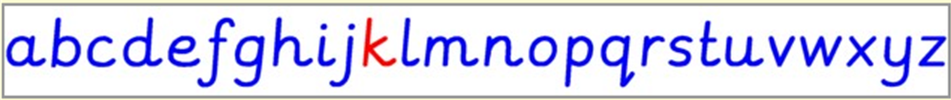

Reading Expectations:
Expected Reading Book Bands:
Autumn Term - Black
Spring and Summer Term – Brown
Please note: This is the book band your child should be reading in school. They may have a different coloured band at home to consolidate skills.
- Use punctuation in the text (commas, question marks & exclamation marks) to vary expression.
- Apply their growing knowledge of root words, prefixes and suffixes, both to read aloud and to understand the meaning of new words they meet.
- Increase their familiarity with a wide range of books and genres. (Read different genres of books, not just choose the same types of books to read).
- Read books that are structured in different ways and notice the similarities and differences between these.
- Discuss words and phrases that catch the reader’s attention and think about why they have been used.
- Answer questions about a text by drawing ideas from more than one paragraph.
- Make predictions and explain their reasoning using evidence from the text.
- Identify how language, structure and presentation contribute to meaning.
- Retrieve information from non-fiction texts.

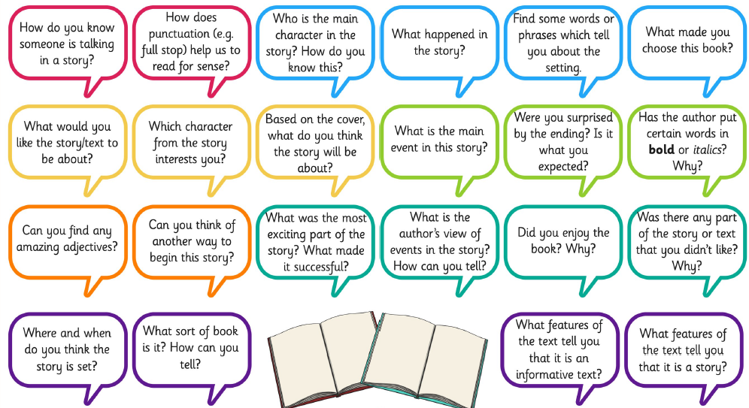
Reading Comprehension Questions.
Asking questions similar to these develops the reading skills required in Year 3.
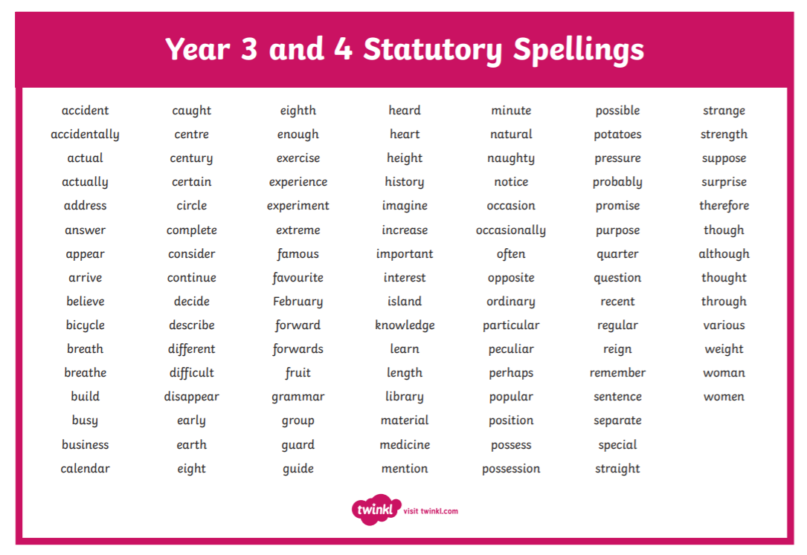
Useful Websites to support learning:

www.ictgames.com
www.phonicsplay.co.uk
www.topmarks.co.uk
www.bbc.co.uk/education
www.crickweb.co.uk
www.nrich.maths.org
www.literacyshed.com
www.oxfordowl.co.uk
www.educationcity.com
www.readtheory.org
www.mymaths.co.uk


