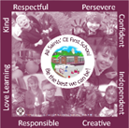

All Saints’ CE First School

End of Year Expectations
for Year 2

This booklet provides information for parents and carers on the end of year expectations as compiled by the staff using National Frameworks/Curriculum requirements.

All the objectives will be worked on throughout the year and will be the focus of direct teaching. Any extra support you can provide in helping your children to achieve these is greatly valued.

If you have any queries regarding the content of this booklet or want support in knowing how best to help your child please talk to your child’s teacher.

Multiplication Tables that all children should know by the end of Year 2.

This means to be able to recall any times table fact and the related division fact from all of these tables.
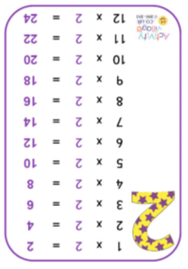
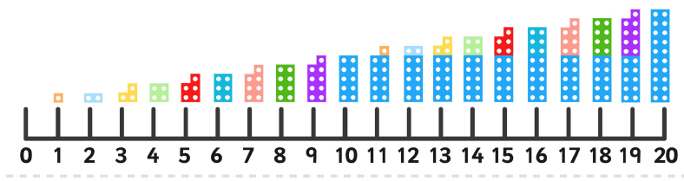
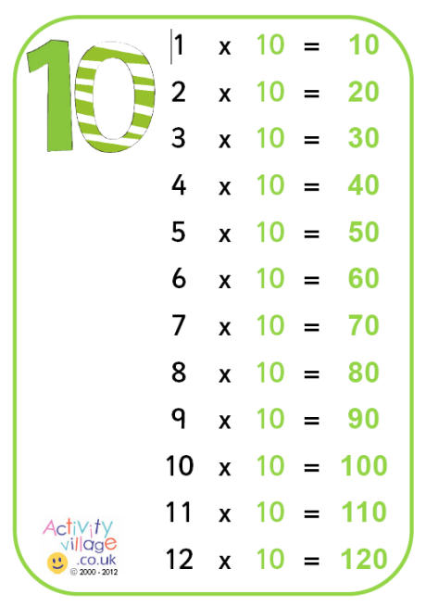
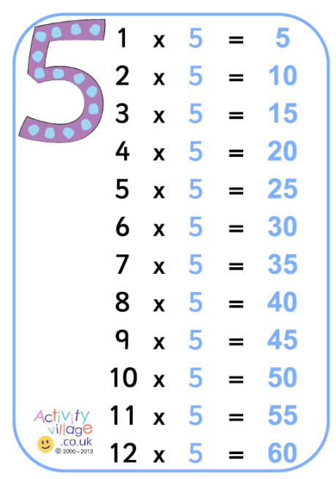
Mathematics Expectations:
- To read & write all numbers to 100 in digits & words.
- To order and compare numbers to 100 using < > =
- To say 10 more/less than any number to 100.
- To count in multiples of 2, 3 & 5 & 10 from any number up to 100.
- To recall & use multiplication & division facts for 2, 5 & 10 tables.
- To recall & use number facts to 10 to inform +/- facts to 20.
- To know the value of coins and make totals
- To recognise the place value of any 2-digit number in tens and ones.
- To partition 2 digit numbers in different ways eg 23 is 20 + 3, 15 + 8, 10 + 10 + 10 + 3
- To add & subtract:
    - 2-digit nos & ones,
    - 2-digit nos & tens,
    - Two 2-digit nos,
    - Three single -digit nos
- To recognise & use inverses (+/-) E.g. 19 + 1 = 20 and from this I know that 20—9 = 1 and in solving missing number problems
- And 5 x 3 = 15 so 15÷ 5 =3
- To solve problems using all four operations.
- To recognise and find fractions of shapes and sets of objects for 1/2, 1/3; 1/4; 2/4; 3/4.
- To tell the time to quarter hours, extending to 5 minute intervals
- To know common 2D and 3D shapes, describing properties such as how many edges, faces etc
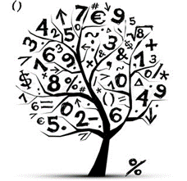


Writing Expectations:

- To write coherent pieces linking ideas in sentences together (real and fictional).
- To read and check sense of own writing
- To write different kinds of sentences
ie. statements, questions, exclamations & commands
- To demarcate most sentences with capital letters and full stops.
- To begin to use other punctuation at times: question marks, exclamation marks, commas, and apostrophes for contraction (I’m instead of I am) or possession ( the dog’s bone)
- To use correct & consistent tense in writing ie past or present tense.
- To use expanded noun phrases, adjectives and description
- To link ideas in sentences using coordination ( and, but, or) and subordination (when, if, that, because).
- To use accurate letter formation – beginning to use some diagonal & horizontal strokes to join handwriting.
- To segment and spell words using plausible phonetic attempts
- To spell many common exception words correctly (See list of common exception words/next 200 )
Reading Expectations:
Under usual circumstances it is expected by Year 2 that children have completed the phonics programme and exited decodeable e books.
Expected Banded Reading Book Bands:
Autumn Term - Turquoise
Spring Term - Purple
Summer Term – Gold/White
Please note: This is the book band your child should be reading in school. They may have a different coloured band at home to consolidate skills.

- To be able to read most common words from sight (Please see a list of the common exception words/next 200 words as a guide).
- To read accurately and independently, checking sense.
- To read using phonics knowledge but without obvious sounding.
- To read ahead with fluency and expression
- To read multi-syllabic and suffixed words in contexts.
- To use commas, question marks & exclamation marks to vary expression and intonation.
- To comment on plot, setting & characters in familiar & unfamiliar stories, sequencing events and making predictions.
- To ask and answer questions from texts.
- To begin to use inference in discussing texts.
- To be able to give a recount of the main themes & events from reading.
- To be able to comment on the structure of the text.
- To be able to identify past/present tense.
- To use contents and index pages to locate information.
- Read a wide range of poetry, stories and non-fiction.
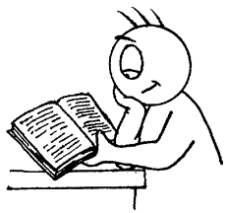
- Recognise recurring language in stories and develop understanding or new or unfamiliar words.

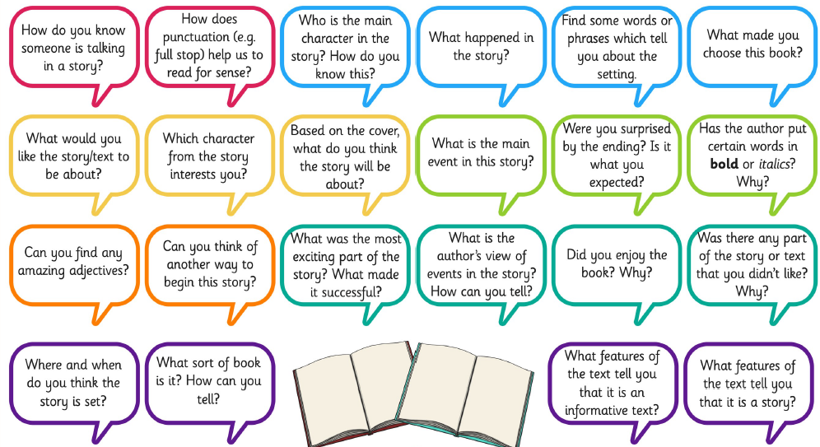
Reading Comprehension Questions.
Asking questions similar to these develops the reading skills required in Year 3.
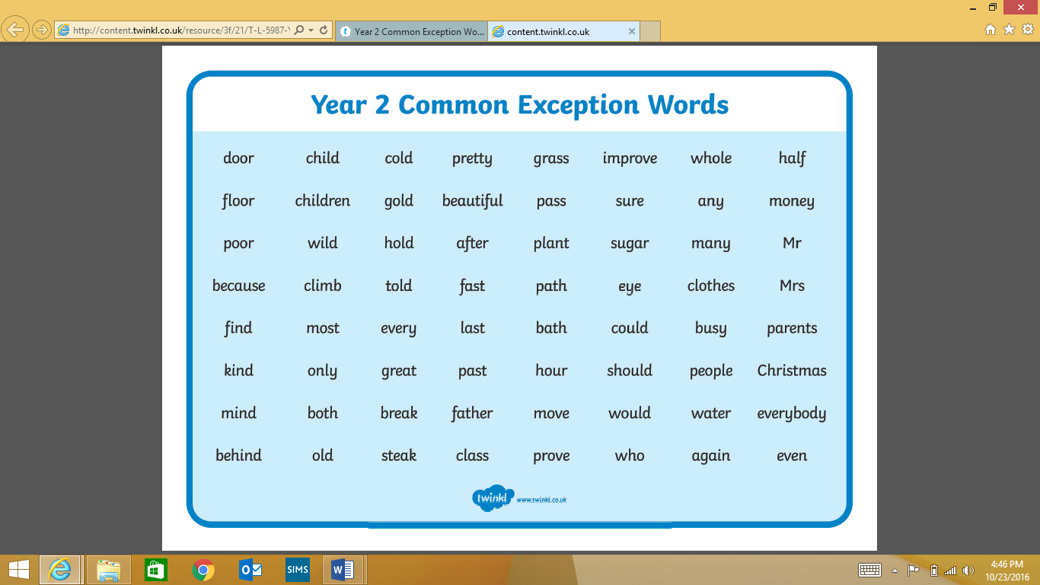
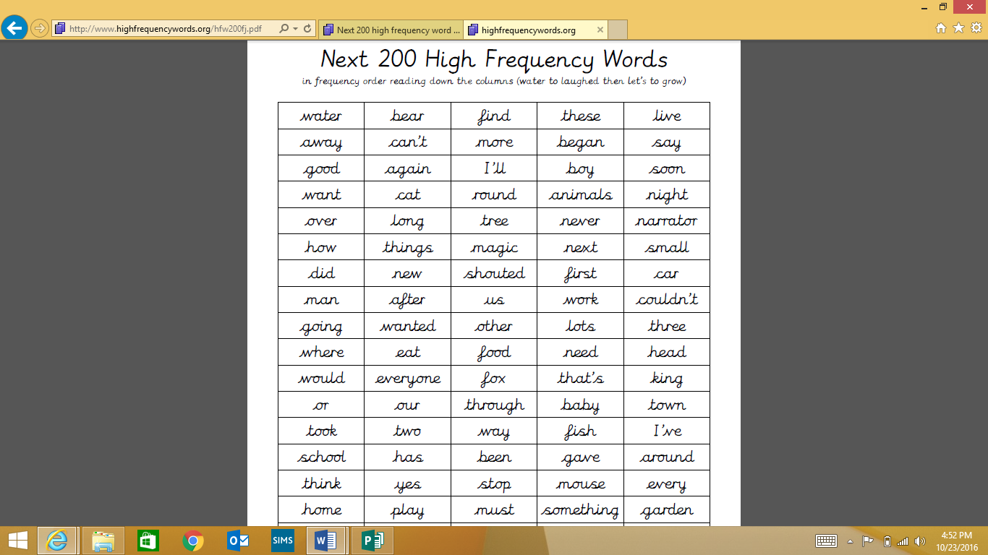
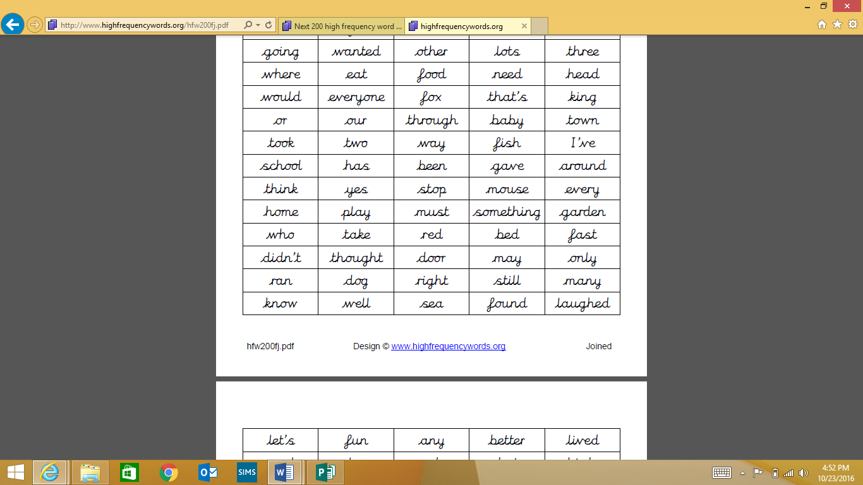
#

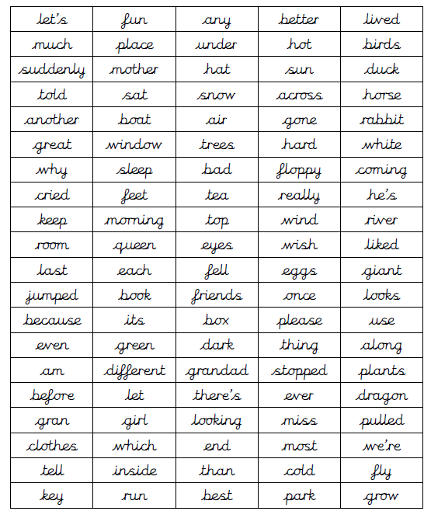

Number Square
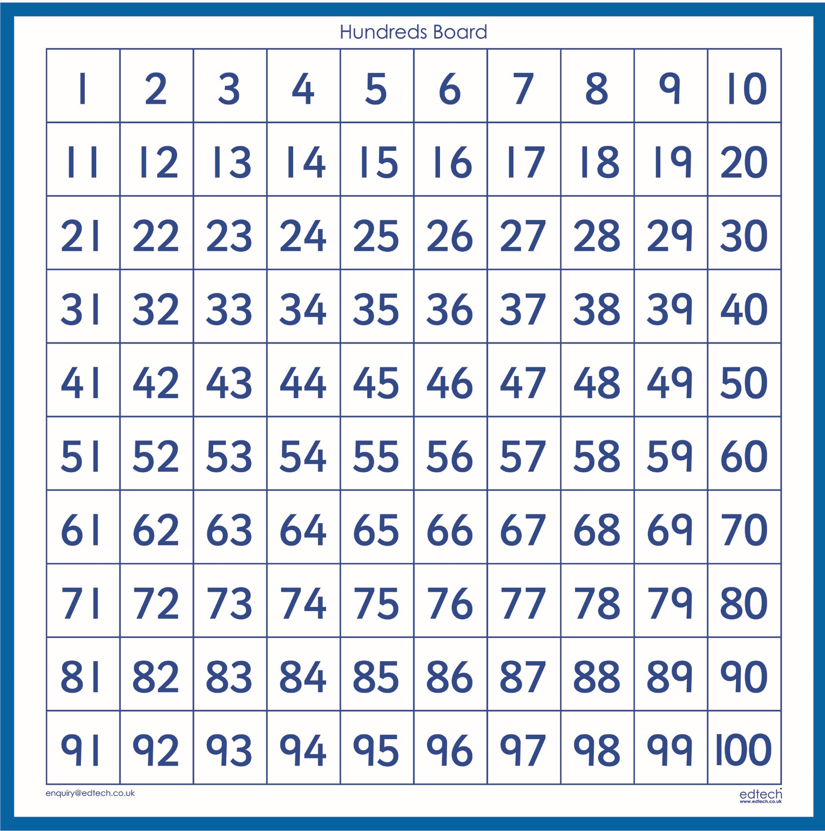

Useful Websites to support learning:
To access e books -https://ebooks.collinsopenpage.com
( login and password on sticker on reading diaries)
www.ictgames.com
www.topmarks.co.uk
https://www.topmarks.co.uk/maths-games/hit-the-button
www.bbc.co.uk/education
www.nrich.maths.org
www.oxfordowl.co.uk
https://www.bbc.co.uk/teach/supermovers/ks1-collection/zbr4scw


