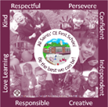

All Saints’ CE First School

End of Year Expectations
for Year 1

This booklet provides information for parents and carers on the end of year expectations as compiled by the staff using National Frameworks/Curriculum requirements.

All the objectives will be worked on throughout the year and will be the focus of direct teaching. Any extra support you can provide in helping your children to achieve these is greatly valued.

If you have any queries regarding the content of this booklet or want support in knowing how best to help your child please talk to your child’s teacher

Number facts to 10 to know by heart and use in number facts to 20
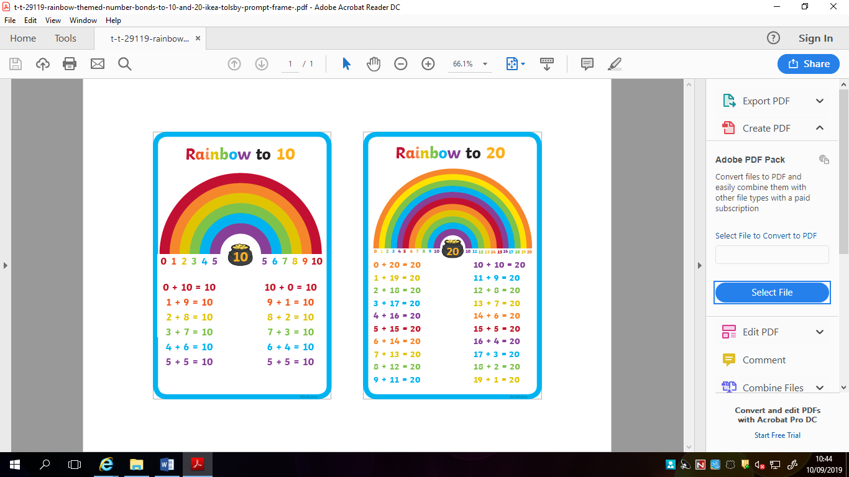

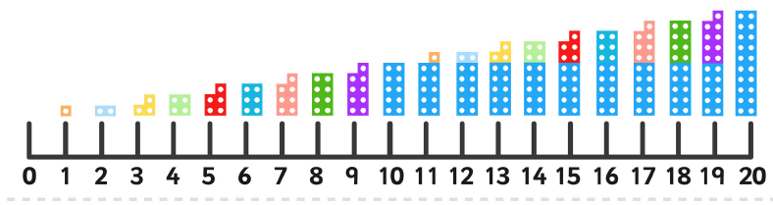
Numicon representation of numbers 1-20
Mathematics Expectations:
- Count, read and write numbers to 100 in numerals;
- Count in multiples of 2s, 5s and 10s from 0
- To say 1more/less than any number within 100.
- Represent and use number bonds and related subtraction facts within 20.
- Add and subtract one-digit and two-digit numbers to 20, including 0.
- Solve one-step problems that involve addition and subtraction.
- Recognise and know the value of different denominations of coins and notes.
- Total coins to the value of 20p
- Solve one-step problems involving multiplication and division, counting in 2s,5s or 10s
- Recognise, find and name a half as 1 of 2 equal parts and quarter as 1 of 4 equal parts of and object, shape or quantity.
- Find half of quantities to 10
- Compare, describe and use language of
- lengths and heights [for example, long/short, longer/shorter, tall/short, double/half
- mass/weight [for example, heavy/light, heavier than, lighter than]
- capacity and volume [for example, full/empty, more than, less than, half, half full, quarter]
- time [for example, quicker, slower,
- Sequence events in chronological order using language [for example, before and after, next, first, today, yesterday, tomorrow, morning, afternoon and evening, days of the week and months of the year]
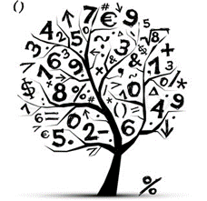
- To tell the time to the hour and half past the hour
- Recognise and name common 2D and 3D shapes.

Writing Expectations:
- Use a mixture of simple and compound sentences using ‘and’ to link ideas.
- Sequence sentences to form short narratives based on fictional and real experiences.
- To begin to read own work and check
- To use finger spaces between words
- To use capital letters and full stops to demarcate some sentences independently.
- To begin to use question marks and exclamation marks to demarcate sentences.
- To consistently use capital letters for the personal pronoun I and begin to use capital for some proper nouns
- Use vocabulary that is appropriate to the subject matter independently.
- Use adjectives for description independently.
- Name the letters of the alphabet in order.
- Form lower case letters in the correct direction, starting and finishing in the correct place with consistency. Form capital letters and digits 0-9 accurately (see separate Little Wandle letter formation pack)
- Segment and spell words using plausible phonetic attempts
- To spell common exception words correctly (See list of Y1 common exception words/high frequency words )


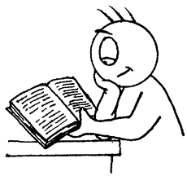
Reading Expectations:
Children will read Little Wandle e books.
They are expected to be able to read all Phase 5 and exit the
programme by the end of Year 1.
Sharing books – end of year corresponding book band orange/turquoise. This is the book
They may have a different coloured band at home to consolidate skills.

- Apply phonic knowledge and skills to decode words
- Know correct sounds to graphemes (letters or groups of letters) for all 40+ phonemes,
- Read accurately by blending sounds in unfamiliar words containing phonemes that have been taught (using sound buttons)
- Read common exception words, noting unusual correspondences between spelling and sound and where these occur in the word (Please see a list of the common exception words/next 200 words as a guide).
- Read words containing–s, –es, –ing, –ed, –er and –est endings
- Read some words with more than one syllable
- Read words with contractions [for example, I’m, I’ll, we’ll],
- Re-read books to build up their fluency and confidence in word reading
- Listen to and discuss poems, stories and non-fiction.
- Link what they read or hear read to their own experiences
- Become familiar with key stories, fairy stories and traditional tales, retelling them and considering characteristics
- Recognise and join in with predictable phrase
- Learn rhymes and poems, and recite some by heart
- Identify rhyming words
- Discuss word meanings
- Check that text makes sense to them as they read and correct inaccurate reading
- Discuss the significance of the title and events
- Make inferences on the basis of what is being said and done
- Predict what might happen on the basis of what has been read so far

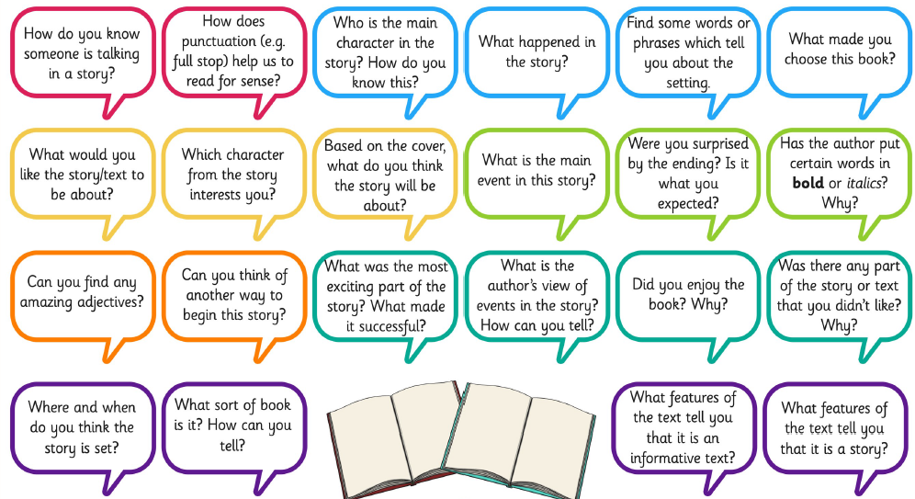
Reading Comprehension Questions.
Asking questions similar to these develops the reading skills required in Year 3.
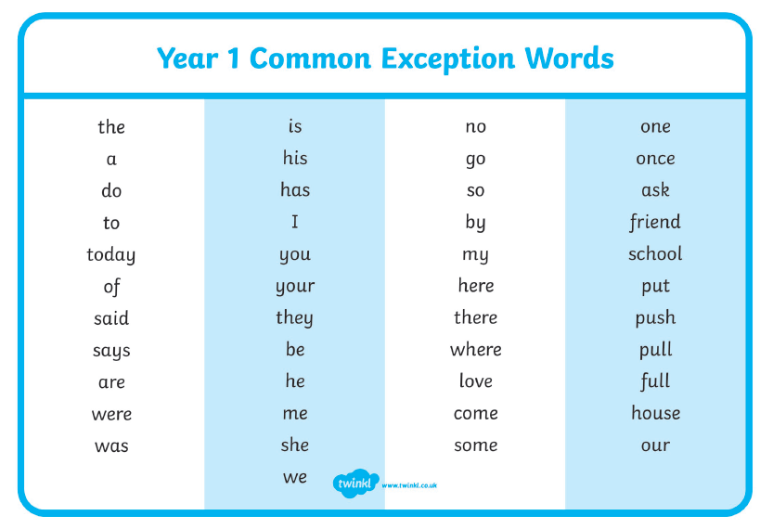
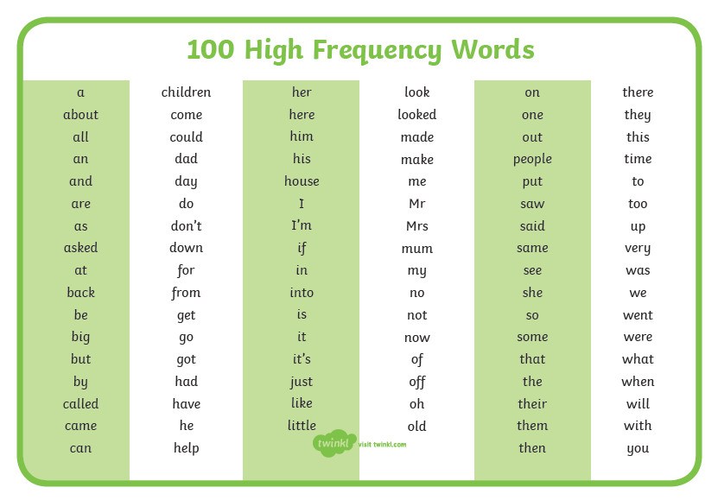
In year 1 children will complete a Phonic screening test.
They will read 20 real and 20 pseudo words, examples below.

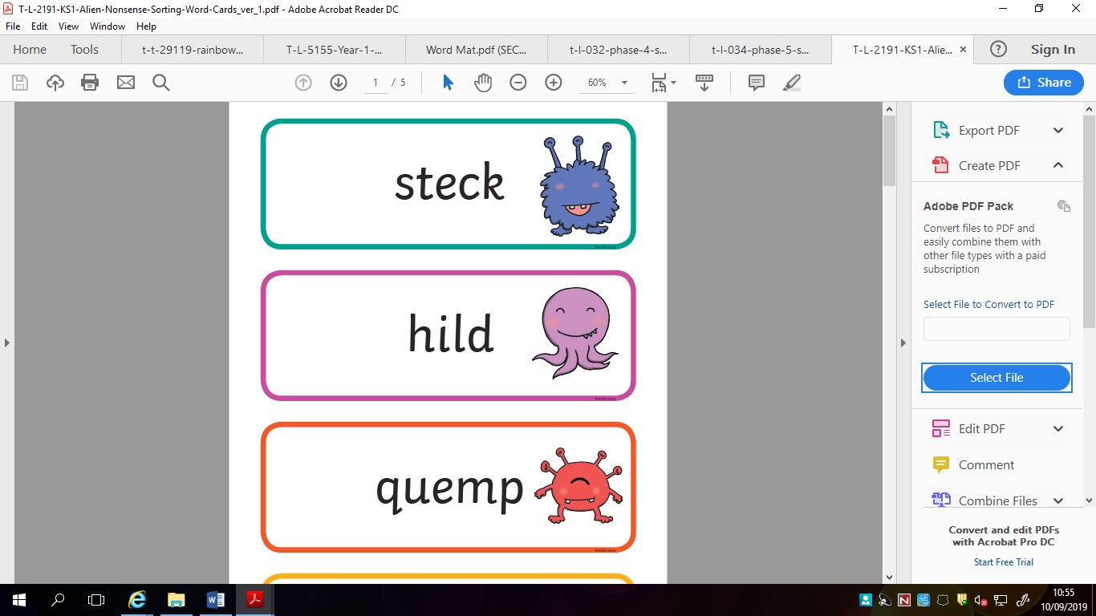

We encourage children to use sound buttons to blend the sounds to read/spell

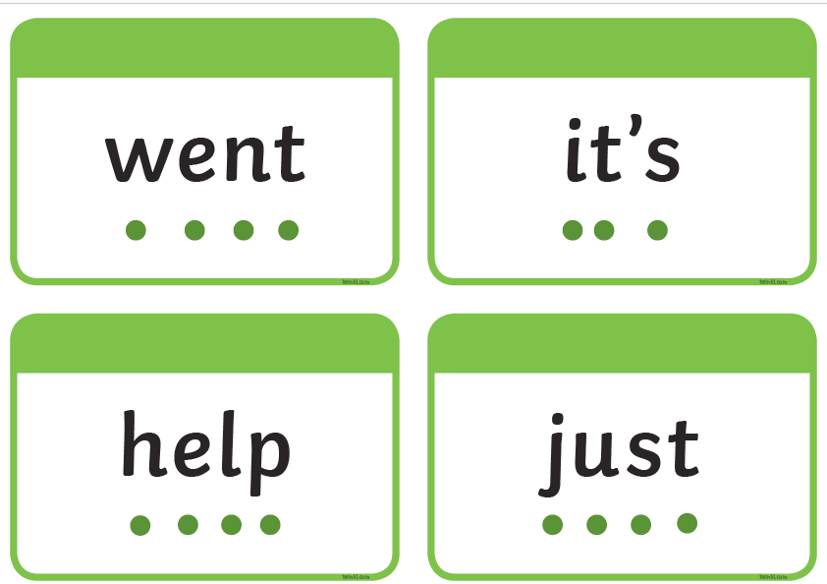

Number Square
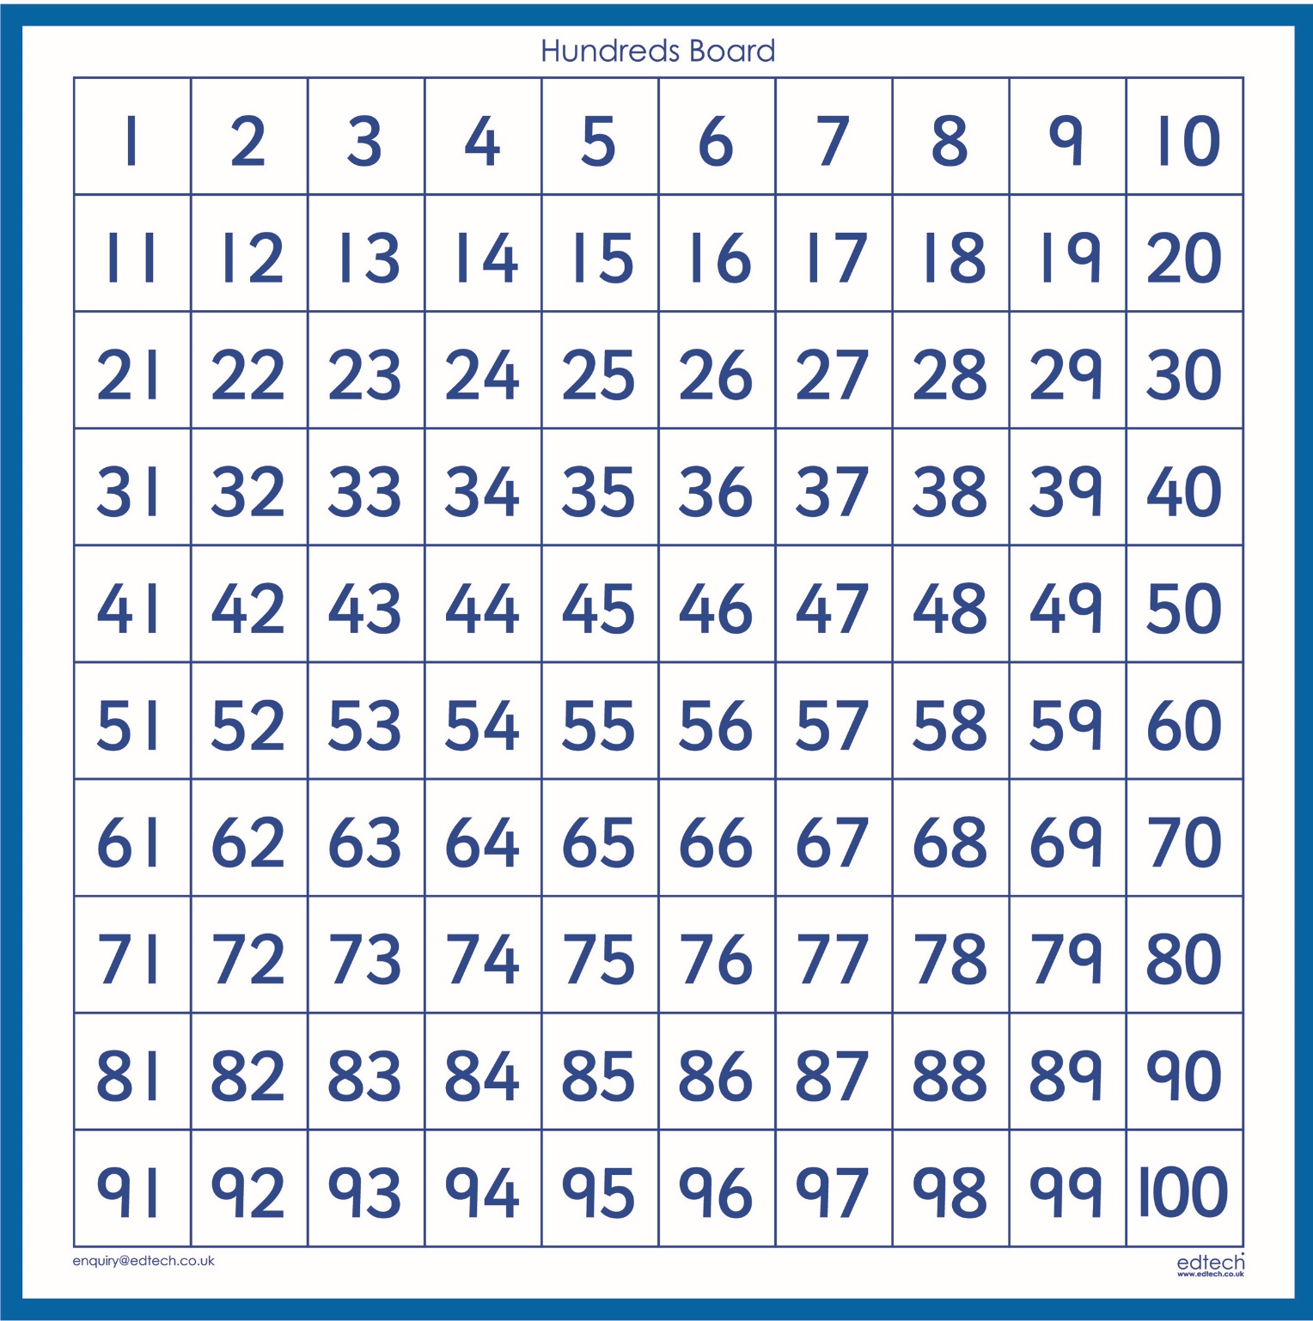

Useful Websites to support learning:
For e books –https://ebooks.collinsopenpage.com
(login and password on the sticker on reading diaries)

www.ictgames.com
www.phonicsplay.co.uk
www.topmarks.co.uk
www.bbc.co.uk/education
www.nrich.maths.org

www.oxfordowl.co.uk

